

Planning Guide
for a
Region-wide
Pathways Training


OPENING MESSAGE/MISSION
As the district draws to a close, so too does the legacy program. The Toastmaster journey is an ever-changing one with new destinations, new challenges, and new opportunities. The Pathways program has been with us for at least a couple years, but there are still many Toastmasters who have not embraced it, plus there is a constant influx of new members who need our help and support.

With the COVID19 lockdown there are even more challenges with online meetings, with new technology and with attendance. But Toastmasters thrive on challenges and this one is not different.

It was with these new challenges in mind that some in Region 7 decided to provide online, region-wide, Pathways training not only for Toastmasters not yet enrolled in Pathways, but also for all our new members. This workbook serves to document our efforts and experiences in putting on such a training session, and will, we hope, make it easier for the next group that may want to host such a training session.

No one person could have performed all the functions required for this event. All those who contributed are listed in Appendix F, with my special thanks.

Sincerely,
Iris
Iris Taylor, DTM
Event Coordinator

ACTIONS REQUIRED/OVERVIEW
If you are planning a Region-wide training event, then all districts in the Region should be represented on the event committee (or at least offered the opportunity to participate).

Each district should in charge of promoting the webinar event as well as providing the instructional materials within their district. One of the District Public Relations Managers could coordinate publicizing the event with the other Districts. In addition, you may want to reach out to your International Director and Regional Advisor(s).

To get started, coordinate with the Program Quality Directors of all districts in the region, and select a Project Manager, an Event Technology Master, a Registration Coordinator, and an Instructor Coordinator.

The Project Manager should have strong leadership qualities, including: goal setting, time-management, good delegation skills, be calm and cool under pressure and be able to oversee a large project.

The Technology Master should be thoroughly familiar with whatever online platform is chosen: Zoom, GoToMeeting, WebEx, Skype for Business, Microsoft Teams, Google Hangouts, etc.

The Instructor Coordinator should have attention to detail and be able to collaborate with all of the instructors, set schedule, and be familiar with the online platform chosen as well as the shared document drive.

One of the first steps should be to put together a small team (of five or less members) to assist with the initial planning stages, develop the training syllabus for each course, reach out to all districts to inform them about the event and to solicit names for potential trainers and room monitors.

EVENTBRITE

WHY USE EVENTBRITE?
It is not mandatory to use Eventbrite, as most video chat platforms will have a registration feature. However, there are many reasons to use it. The foremost reason – It’s Free! It’s free if you do not charge for your event. Eventbrite is a robust, web-based, event management software that will help manage ticket distribution, promotion, information collecting and more, for your event.

EASILY EMAIL EVENT ATTENDEES
Eventbrite makes it easy to communicate with your event attendees with a built-in email system. A reminder email is automatically generated, which sends 24-hours prior to the start of your event.

SOCIAL MEDIA PROMOTION TOOLS
Eventbrite integrates with Facebook and will tell event goers which of their friends will be attending the event as well.

SAMPLE EVENTBRITE INVITATION
See Appendix A for an actual Eventbrite invitation.

Eventbrite was chosen to register participants. For the 25 available sessions (5 courses for 5 time slots), a ticket was created for each one. Within the instructions for registration, registrants were instructed twice to only select one course per time slot. That means a member could take all 5 courses if he or she stayed for the entire ten hours. Once they decided on the courses they want to take, the registration coordinator would use Eventbrite to compile a list of all the people registered for each course. The registration coordinator would then give the registration list to the respective instructor. Within the Eventbrite management system, once a person has successfully registered for a course, he or she would receive an email with instructions to download Zoom with the link to join the Zoom meeting.

TECHNOLOGY MASTER
Zoom is the leader in modern enterprise video communications, with an easy, reliable cloud platform for video and audio conferencing, chat, and webinars across mobile, desktop, and room systems. Zoom Rooms is the original software-based conference room solution used around the world in board, conference, huddle, and training rooms, as well as executive offices and classrooms.

Zoom is free to everyone, with a 40-minute time limit per meeting. This feature allows participants to practice using the Zoom features to perfect their skills.

Zoom offers several options and any district can afford the $20/month plan that will accommodate up to 500 people online at the same time.

Your Technology Master should be highly proficient with whatever online platform you choose, including: chat, breakout rooms, waiting room, main room, controlling entry into breakout room, assigning hosts (In Zoom, there can be only one host, who has the only authority to divide participants into breakout rooms) and co-hosts, muting, and all features necessary to run a large online meeting. In addition, they should:
- Create the individual breakout rooms prior to or at the start of the event
- Open the event
- Optional: Having a welcoming plenary session within the main room
- Set up the invitation to be used by each district
- Set up event platform (we used Zoom)
- Open the event
- Divide participants into their classrooms (we asked everyone to rename themselves by adding the initials of the class they were attending in front of their names., for example: BAS Karen Storey meant Karen Storey was going to Pathways Basic, INT = Intermediate, ADV = Advanced, BCM = Base Camp Manager, and MYT DIS = Dispelling the Myths. INS as a prefix denoted the person was an Instructor. MON as a prefix denoted the person was a Room Monitor.
- Close the event rooms
- Send participants an evaluation form after the event is closed (Cognito Forms or Survey Monkey allows you to send the survey for free.
PROJECT MANAGER
The Project Manager should have strong Zoom experience, be calm and cool under pressure, be able to multi-task and be fully familiar with the classroom schedule and know which instructor/room monitor pair belongs with which breakout room.

Important things to have on the day of:

  - A printed agenda
  - A printed matrix showing room assignment; time slot and the instructor/monitor pair that belongs to each room.
  - A printed syllabus for each course
  - A list of phone numbers and email addresses for each instructor and room monitor
  - An introduction for each instructor – so they can be emailed in event the room monitor fails to show up

Invite a ‘special’ guest to do a mini-keynote (one or two minutes) to kick off the event. Make sure you have their introduction/bio. Consider recording it in advance – that way it can be played over and over at the start of each course period. You will also have a consistent message and there will be no need to worry about the speaker showing up for the event.

INSTRUCTORS/ROOM MONITORS
Finding knowledgeable and engaging instructors is essential to the success of this event.

Start by contacting the Program Quality Directors to see who they would recommend.

Our event was centered around this concept:

Event | 9:00 am – 11:00am | 11:00 am – 1:00 pm | 1:00 pm – 3:00 pm | 3:00 pm – 5:00 pm | 5:00 pm – 7:00 pm
Basic | Instructor/Monitor | Instructor/Monitor | Instructor/Monitor | Instructor/Monitor | Instructor/Monitor
Intermediate | Instructor/Monitor | Instructor/Monitor | Instructor/Monitor | Instructor/Monitor | Instructor/Monitor
Advanced | Instructor/Monitor | Instructor/Monitor | Instructor/Monitor | Instructor/Monitor | Instructor/Monitor
BC Manager | Instructor/Monitor | Instructor/Monitor | Instructor/Monitor | Instructor/Monitor | Instructor/Monitor
PW Myths | Instructor/Monitor | Instructor/Monitor | Instructor/Monitor | Instructor/Monitor | Instructor/Monitor

BC Manager = Base Camp Manager / PW Myths = Pathway Myths
Important items to consider:
- List with each instructor’s name, phone number and email
- List with each monitor’s name, phone number and email
- Printed matrix showing instructor/monitor pair’s time slot, subject and breakout room
- A proper introduction for each instructor (in a format that can easily be emailed to the room monitor or their replacement)
- Host a couple Zoom sessions to simulate the actual event
- Review instructors prepared material for accuracy and branding

See Appendix E for a list of our trainers and room monitors.

COURSE DESCRIPTION/PLANNING, PART 1
It was decided that five Pathway related classes would be offered: Dispelling Myths about Pathways, Basic, Intermediate and Advanced and classes on Pathways, plus Base Camp Managers.
Course 1: Dispelling Myths about Pathways

Pathways can seem like this giant that some people feel they have no chance of understanding. You can do this! Others have misconceptions about Pathways, which spread to other Toastmasters until it becomes an incorrect belief. This course will touch on the most common myths and misconceptions of Pathways then separate fact from fiction. The course will also allow you to see how accessible Pathways can be once you have the right knowledge.

- Course 2: Basic Pathways

If you have not yet registered for Pathways online or have only logged in once or twice, this is the course for you! Also, for members new to Toastmasters and those who are transitioning from the legacy program to Pathways. This course will define some of the terminology used in Pathways, teach you how to access Pathways, help you determine which path you would find most useful or enjoyable, and teach you to navigate through Base Camp. From terminology and acronyms to completing a Pathways level, this course will cover the basics to get you started on Pathways

- Course 3: Intermediate Pathways

For those who are familiar with Pathways but do not consider themselves as experts, this course will review the basic concepts of Base Camp. You will also learn more about the Pathways elective projects, navigating through the education transcripts, how to search for members within your club, provide feedback and award badges. This course will teach you to be more proficient with Pathways and be more familiar with its features.
.

COURSE DESCRIPTION/PLANNING, PART 2

Course 4: Pathways for Base Camp Managers (offered to all current and incoming: Club Presidents, Vice Presidents of Education, and Secretaries)
If you are the President, Vice President of Education, or Secretary of your club, then you are also a Base Camp Manager for that program year. This course will cover the duties of a Base Camp Manager. It will also provide training on how to approve completion of a Pathways level, how to track the progress of your club members and additional responsibilities and best practices for Base Camp Managers.
Course 5: Advanced Pathways

For those who are familiar with Pathways and have attended numerous training sessions regarding Pathways, this course will cover how to earn your Distinguished Toastmasters (DTM) Award. It will also cover and discuss the Pathways Mentor program as well as delve more into the complexities of Pathways.

The five (5) courses will be offered at multiple times throughout the day from 9 a.m. to 7 p.m. Each course will be 1 hour 30 minutes long with 30 minutes for Q & A. Our instructors will dispel the myths and help you utilize the benefits of Pathways with your Toastmasters club.

Time Slots (5) - You may sign up for all five (5) time slots, but you can only register for 1 course per time slot.
9:00 am - 11:00 am
11:00 am - 1:00 pm
1:00 pm - 3:00 pm
3:00 pm - 5:00 pm
5:00 pm - 7:00 pm

Course List (5) - All five (5) courses will be offered at all five (5) time slots, for a total of 25 sessions. Please note that you sign up for all five courses, you are registering to stay for the ENTIRE 10 hours. (Each course is about 2 hours x 5 courses = 10 hours).

EVENT PLANNING
  - Select the following coordinators
- Program Manager (Overall event)
- Eventbrite
- Advertising (fliers, Facebook, email, etc.)
- Zoom
- Scheduling
  - Find instructors and monitors
  - List of trainers and monitors with email addresses and phone numbers
- Determine course descriptions
    - Number of courses offered
    - Schedule of each course
    - Times of courses offered
    - Length of courses
    - Syllabus
    - Material presentation (PowerPoint, online, etc.)
  - Technology Manager, Registration Manager, or Program Manager
  - Admitting participants
  - Moderators
  - Breakout room assignment
  - Guest speaker

DISCLAIMER
Read this prior to the introduction of each instructor for each session.

By attending this remote webinar event, you agree to the privacy policy of Toastmasters International as well as the unassociated remote hosting service. Some of your personal information, such as name, image, and any shared messages may be shared with other meeting participants and will be recorded by Toastmasters International who may use the recording in the future as it sees fit. Your remote attendance hereby discharge Toastmasters International from all claims, demands, rights, promises, damages and liabilities arising out of or in connection with the use or distribution of said video recordings, including but not limited to any claims for invasion of privacy, appropriation of likeness or defamation.

RANDOM THOUGHTS, Part 1
Course Offerings
There were 25-sessions throughout the day. All five classes were run simultaneously, beginning on the hour and lasting two-hours. Some instructors only wanted to present once, others were willing to present multiple sessions, a couple sessions were done with two instructors sharing time during their two-hour session.
Our group initially decided that the following courses be offered: Basic Pathways, Intermediate Pathways, and Advanced Pathways. As time went on, Pathways for Base Camp Managers and Dispelling Myths about Pathways were added.
Number of Monitors
Each breakout session required at least one room monitor. The room monitor duties included: introduction of instructors, monitoring chats so instructors were not distracted, ensuring participants were muted, read the disclaimer statement and had video off during presentation, and reading the chat and asking questions of the presenter on behalf of the participants.
Assignment of Instructors by topic and time slot
Instructors were selected based on their interest and expertise in a topic. Assignment of time slots was based on instructor preference.
How Courses were to be presented
Each instructor could decide how to present his or her material. For example: direct access to Toastmasters International material, PowerPoint presentations, in Excel, Word, homemade presentations or a combination of all.
Decide on online platform
Zoom was chosen because of all of its features and because it allows each member to have their own Zoom account indefinitely (meetings are limited to 40 minutes), but at least everyone can sign in with a partner and hold a dry run. Zoom also allowed breakout rooms for each separate course and has a user-friendly interface.
RANDOM THOUGHTS, Part 2
Facebook, district websites, direct to email

Each district may decide how they want to advertise and promote the event: Facebook, district websites, Twitter, Instagram, LinkedIn, Conferences, Club Meetings, and Speech Contests
Event flier
Design an eye-catching, informative flier with all the classes, time slots, the registration link (or Zoom registration link), and all pertinent information. Send to all districts for posting on their website and for distribution.

APPENDIX A – SYLLABUS: PATHWAYS BASIC, PART 1

- Pathways terminology
- Assessment
- Base Camp
- Base Camp Manager
- Club Central
- Paths
- Levels
- Projects
- Web Tutorial
- How to begin
- Login
- Go to Welcome – your name appears
- Go to Base Camp
- Choose a path
- View the Navigator
- View personal profile
- Personal data and review historical information
- Explain how pulldown menus work (in maroon ribbon)
- Home
- Tutorials and Resources
- Check compatibility
- How to use search window: enter member’s name, project name, badges, feedback, etc.
- Explain blue navigation tiles
- Navigating Tips – click Pathways icon (top left) to return to base camp start. Click Return to Start (at bottom, maroon ribbon) to return to home page – will be demonstrated.

APPENDIX A – SYLLABUS: PATHWAYS BASIC, PART 2

- What is under the Pathways link.
- Learn more  - Start page  - FAQ | - Choose a path  - Go to base camp  - Pathways updates | - The Navigator  - Accessible materials

- Enter Base Camp – review 5 tiles
- Navigating Base Camp | - My Badges
- Education Transcript | - Speech Evaluations
- My Feedback
- Demonstrate project launch and completion
- Level completion requirements
- Advanced Mentoring and the DTM Project

APPENDIX A – SYLLABUS: PATHWAYS INTERMEDIATE

- Review Pathways terminology
- Basic Structure
- Levels
- Projects
- Paths
- Core Competencies
- How to use search window: enter member’s name, project name, badges, feedback, etc.
- Navigating Tips – click Pathways icon (top left) to return to base camp start. Click Return to Start (at bottom, maroon ribbon) to return to home page – will be demonstrated.
- Enter Base Camp – review 5 tiles
- Navigating Base Camp | - My Badges
- Education Transcript | - Speech Evaluations
- My Feedback
- Demonstrate badges/feedback
- Elective Projects
- Highlight several elective projects
- Navigating Base Camp
- Find and show videos

APPENDIX A – SYLLABUS: PATHWAYS ADVANCED

- Earning a DTM under Pathways
- Complete two learning paths
- Serves a club office for 12-months (can be six months in two officer roles)
- Attend district sponsored training
- Participate in preparation of Club Success Plan
- Serves one year as a district officer
- Serve successfully as a club mentor or club coach
- serve successfully as a club sponsor, conduct a Speechcraft or Youth Leadership
- Complete DTM Project
- Requirements
- Selecting a Project
  - Pathways Mentor Program – becomes active once you reach your second level
- Prepare to Mentor
- Mentoring
- Advanced Mentoring

APPENDIX A – SYLLABUS: BASE CAMP MANAGER, PART 1

- Base Camp Manger – introduction
- How to Login as Base Camp Manager
- Base Camp Glossary
- Frequently asked questions
- Base Camp Manager initial screen
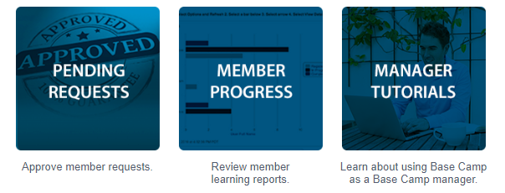
- Tutorials and Resources
- Review tutorials related to Base Camp Manager
- Base Camp Manager Overview
- External Training Dashboard
- Individual Progress Dashboard
- Level Completion Overview
- Path Completion in Printed Materials Overview
- Path Progress Dashboard
- Path Type Dashboard
- Printing Certificates (Paths in Print)
- Printing Certificates (Paths on Base Camp)
- Project Information and Resources Overview

APPENDIX A – SYLLABUS: BASE CAMP MANAGER, PART 2

- Projects Outside Our Club Overview
- Recently Selected Paths Dashboard
- Responding to External Training Completion Requests
- Responding to Initial External Training Requests
- Responding to Level Completion Requests (Paths on Base Camp)
- Tracking Progress Overview
- Tutorial Quick Reference Guide: External Training Dashboard
- Validating Project and Level Completions (Paths in Print)
- Tutorial Quick Reference Guide: External Training Dashboard
- Pending Requests: Approve member requests.
View outstanding training requests you must approve, defer, or deny. Deferring a request will send the request to the next person in the approval chain for that employee. Click on the employee's name to view their transcript. If you would like others to make approvals on your behalf, you may share your approving permissions for users for whom you are the following:
- Member Progress: Review member learning reports.
- Individual Progress
- Level Completions
- Path Progress
- Path Type
- Recently Selected Paths
- External Training
- Manager Tutorials: Learn about using Base Camp.
- Base Camp Manager Overview
- Project Information and Resources
- Project Information and Resources Overview
- Viewing Another Club Member's Profile
- Tracking Your Meeting Roles
- Searching and Browsing on Base Camp

APPENDIX A – SYLLABUS: BASE CAMP MANAGER, PART 3
- Level Completion
- Level Completion Overview
- Responding to Level Completion Requests (Paths on Base Camp
- Printing Certificates (Paths on Base Camp)
- Path Completion – Printed Materials
- Path Completion in Printed Materials Overview
- Validating Project and Level Completion (Paths in Print)
- Printing Certificates (Paths in Print)
- Projects Outside Our Club
- Projects Outside Our Club Overview
- Responding to Initial External Training Requests
- Responding to External Training Completion Requests
- Tracking Progress
- Tracking Progress Overview
- Individual Progress Dashboard
- Path Progress Dashboard
- Path Type Dashboard
- Recent Registrations Dashboard
- External Training Dashboard

APPENDIX A–DISPELLING MYTHS ABOUT PATHWAYS
Here is the outline of my presentation and what it will cover. Each of the Myths will be explained away with the truth. Bethany Richard, DTM

Dispelling Myths about Pathways

Introduce topic and presentation organization
Myths about Pathways, Paths, DTM, then Q&A
Myths about Pathways:
- It is too hard
- I need a guru to help me
- It is only speeches and dropped “Where Leaders are Made”
- Online learning is endless webinars
- I am too old
Myths about Paths
- My path belongs to my club
- I get a free Path for each club I join
- My Path must be online
- FreeToastHost says I’m on the Dynamic Leadership Path
- VPE should approve all Level Completion Requests
- Once a Level is approved in Basecamp, it will automatically show up in the DCP
Myths about DTMs
- No more credit for DCP
- Two completed Paths = DTM
- DTMs are Rock-stars, Leaders and perfect speakers
- I can still work in the old education system next year

APPENDIX B – EVENTBRITE NOTIFICATION, PART 1

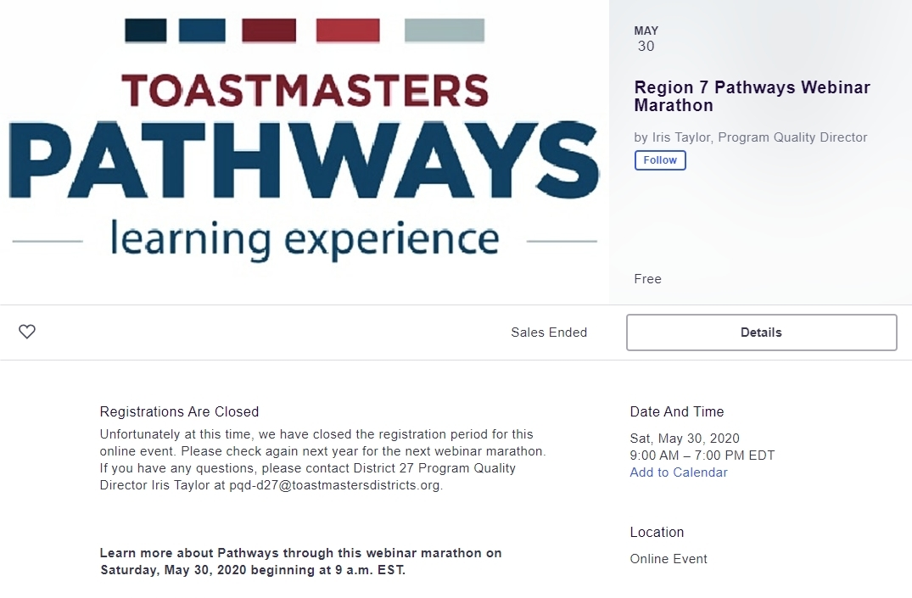

APPENDIX B – EVENTBRITE NOTIFICATION, PART 2

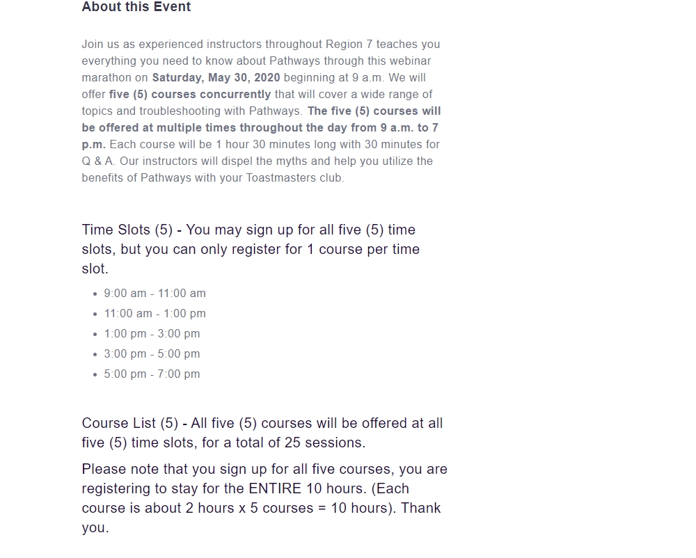

APPENDIX B – EVENTBRITE NOTIFICATION, PART 3

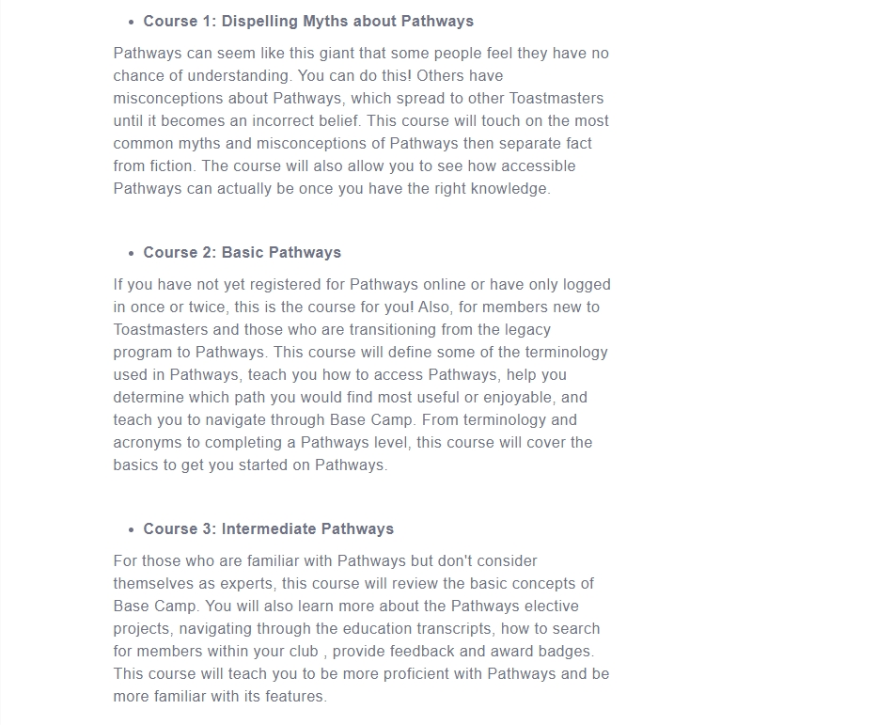

APPENDIX B – EVENTBRITE NOTIFICATION, PART 4

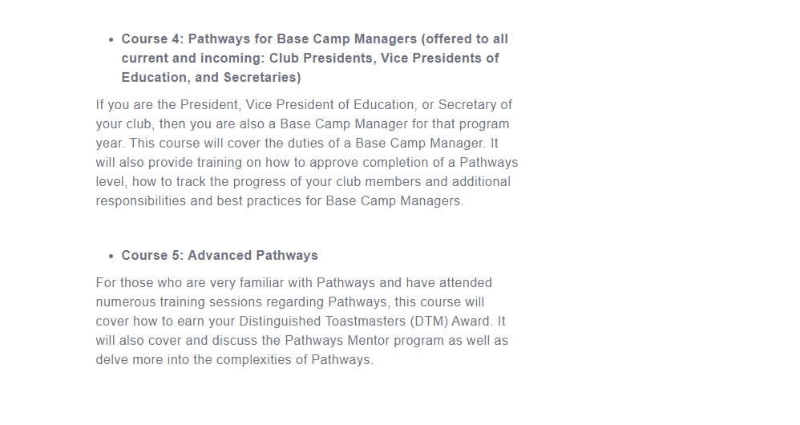

APPENDIX C – EVENT FLIER

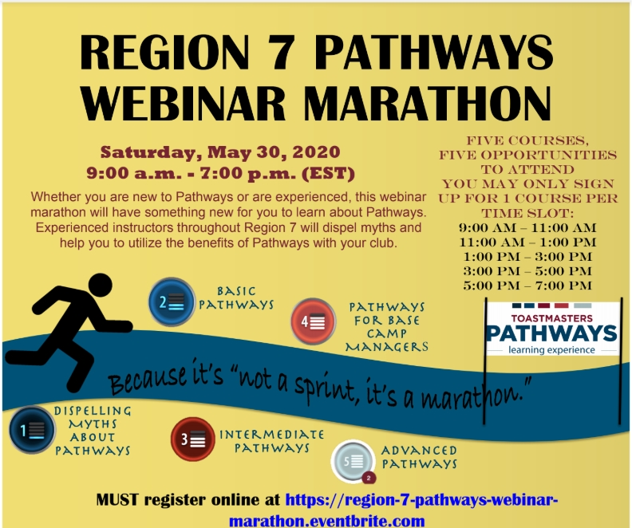
APPENDIX D – SAMPLE TIMELINE

9:00 am District Director Introduces Regional Advisor/Special Guest
9:10 am Sent participants to their assigned course (see above)
9:15 am Course Begins
10:30am Questions
10:40am Send back to main room for a short break
11:00 am District Director Introduces Regional Advisor/Special Guest
11:10 am Sent participants to their assigned course (see above)
11:15 am Course Begins
12:30 am Questions
12:40 am Send back to main room for a short break
1:00 pm District Director Introduces Regional Advisor/Special Guest
1:10 pm Sent participants to their assigned course (see above)
1:15 pm Course Begins
2:30 pm Questions
2:40 pm Send back to main room for a short break
3:00pm District Director Introduces Regional Advisor/Special Guest
3:10pm Sent participants to their assigned course (see above)
3:15pm Course Begins
4:30pm Questions
4:40pm Send back to main room for a short break
5:00pm District Director Introduces Regional Advisor/Special Guest
5:10pm Sent participants to their assigned course (see above)
5:15pm Course Begins
6:30pm Questions
6:40pm Send back to main room for ending comments
7:00 pm End of training

APPENDIX E – COLLABORATION TEAM, PART 1
No event of this size could have been done without the hard work and dedication of a lot of great Toastmasters. The following is a list of those who contributed:
- Project Manager: Iris Taylor, DTM, (D27)
- Contributors, Program Quality Directors
- Cynthia Williams (D18)
- Iris Taylor, DTM (D27)
- Narayann Doraswamy, DTM (D29)
- Joel Palachuvattil, DTM (D36)
- William Tyree, DTM (D66)
- Technology Master: Jeanna Lee (D27)
- Event Flier: Jeanna Lee (D27), Joel Palachuvattil, DTM (D36)
- Instructor Coordinator: Jeanna Lee (D27), Jennifer Ferguson (D27)
- Syllabus Development: Frank Storey, DTM, and Karen Storey, DTM (D18)
Instructors and Room Monitors
Course Times | Dispelling Myths About Pathways
9 am - 11 am | Barbara Linsmeier/Basha McCruumb
11 am - 1 pm | Barbara Linsmeier/Basha McCruumb
1 pm - 3 pm | Jenny Genser White/Barbara Linsmeier
3 pm - 5 pm | Bethany Richard/Michelle St. Pierre
5 pm - 7 pm | Bethany Richard/David Matthews

Course Times | Basic Pathways
9 am - 11 am | Frank and Karen Storey
11 am - 1 pm | Frank and Karen Storey
1 pm - 3 pm | LaShawn Foster/Gary D. Skyers
3 pm - 5 pm | LaShawn Foster/Alonzo White
5 pm - 7 pm | Tom Holloway/Alonzo White

APPENDIX E – COLLABORATION TEAM, PART 2

Course Times | Intermediate Pathways
9 am - 11 am | Jenny Genser White/ Robin Hylton
11 am - 1 pm | Janice Strachan/Ginamarie DeMilio
1 pm - 3 pm | Carlos Velazquez/Michelle St. Pierre
3 pm - 5 pm | Carlos Velazquez/Gary D. Skyers
5 pm - 7 pm | Janice Strachan/Ginamarie DeMilio

Course Times | Pathways for Base Camp Managers
9 am - 11 am | Chalese Gilmore/Janice Strachan
11 am - 1 pm | Chalese Gilmore/Naomi Carrington-Hockman
1 pm - 3 pm | Jim Dooley/Beverly Byam-Hercules
3 pm - 5 pm | Oscar Zalamia/Patricia Weng
5 pm - 7 pm | Jim Dooley/Beverly Byam-Hercules

Course Times | Advanced Pathways
9 am - 11 am | Naomi Carrington-Hockman/ Beverly Byam Hercules
11 am - 1 pm | Judy Olbrych/Jenny Genser White
1 pm - 3 pm | Naomi Carrington-Hockman/Janice Strachan
3 pm - 5 pm | Bonnie L. Maidak/Ginamarie DeMilio

APPENDIX E – COLLABORATION TEAM, PART 3

CONTACT INFORMATION FOR ALL HELPERS
District | Name | Email Address
18 | Cynthia Williams | mscdwilliams0811@gmail.com
18 | Frank Storey | fstorey1943@gmail.com
18 | Karen Storey | karen@karenstorey.com
18 | Oscar Zalamia | ozalamia@gmail.com
27 | Alonzo White | alonzonk@gmail.com
27 | Barbara Linsmeier | linsbar@yahoo.com
27 | Carlos Velazquez | carloslatino3@gmail.com
27 | Gary D. Skyers | gdskyers@outlook.com
27 | Ginamarie DeMilio | gmdemilio2@gmail.com
27 | Iris Taylor | Itaylor0519@gmail.com
27 | Jeanna Lee | jginlee@gmail.com
27 | Jenny Genser White | jenny.genser@verizon.net
27 | Jim Dooley | jim.dooley@scoutpack.org
27 | LaShawn Foster | lashawn.s.foster@gmail.com
27 | Naomi Carrington-Hockman | tmcarringtonhockman@gmail.com
27 | Patricia Weng | patriciaweng@hotmail.com
27 | Tom Holloway | tom.holloway@faa.gov
29 | Bethany Richard | bb_richard@hotmail.com
29 | Beverly Byam-Hercules | bbyam14381@gmail.com
29 | Chalese Gilmore | lese1030@icloud.com
29 | David Matthews | toastmasterdavematthews@gmail.com
36 | Bonnie L. Maidak | blmtm2009@yahoo.com
36 | Janice Strachan | janice.strachan@usda.gov
36 | Joel Palachuvattil | joel.palachuvattil@district36.org
38 | Basha McCrumb | tmbashajo@gmail.com
66 | Judy Olbrych | judy@judyolbrych.com
66 | Ralph Jackson | today4rj@verizon.net
66 | William D. Tyree III | pqdirector@tmdistrict66.org
27/29 | Michelle St. Pierre | brickhouse61@gmail.com

APPENDIX F – TESTIMONIALS

“I was amazed at the conceptual level of the day. I thought it was a great use of the technology to enable us to have so many sessions at one time. It was great for us to be able to choose the sessions we want. It was great not to have to drive; find the right place; find the right room; not look for parking.”

“I loved being a part of the learning process on how to run this huge project! I thought everyone did really well problem solving very efficiently!”

“I found the Pathways Marathon to be well designed and helpful. The concurrent sessions throughout the day made it accessible so that I could attend the sessions I needed when it fit my schedule. Thank you very much for all of the hard work that went into making this available and successful!”

“It was the best experience I ever had in Toastmasters! Learning beside other fellow Toastmasters. I feel empowered to train others on Pathways.”

APPENDIX G – WELCOME SLIDE, SAMPLE 1
Why not welcome participants with a welcome slide at the start of each session? This also serves to let them know they are in the right session, the length of the session and who the instructor is.

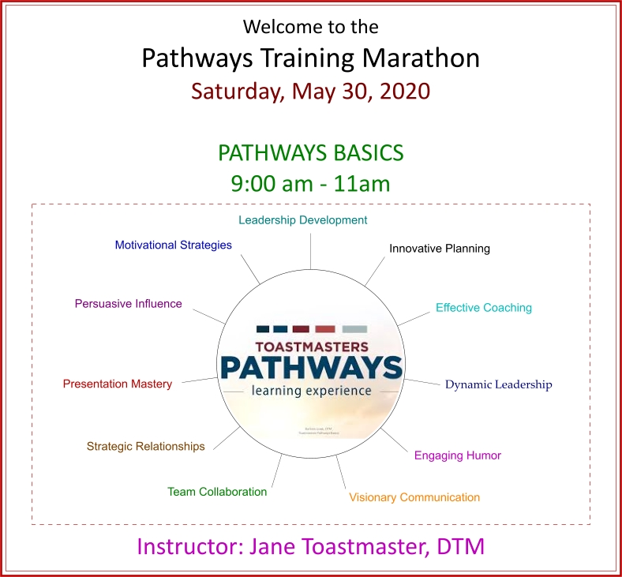

APPENDIX G – WELCOME SLIDE, SAMPLE 2

